**Lab 10**

**Objectives**

The objective of this lab is to develop GPSS simulation models for analyzing real-world service and inspection systems by applying the concept of storage to manage multiple servers. The first scenario aims to simulate a manufacturing process where parts are produced at regular intervals and sent for inspection, utilizing a storage block with 3 servers to represent inspectors and handling variable inspection times and rejection rates. The second scenario models a fuel station where vehicles arrive randomly and are serviced by limited nozzles, simulating customer wait times and service efficiency. These simulations help in understanding resource allocation, bottlenecks, and system performance under varying loads and conditions.

**Q.1. A machine tool in a manufacturing shop is turning out parts at the rate of every 5 minutes. When they are finished, the parts are sent to an inspector, who takes 4±3 minutes to examine each one and rejects 15% of the parts. Write a GPSS program to simulate using the concept of storage. (Here storage has 3 servers and timing parameters are changed.)**

**Source Code:**

GENERATE 5,,,1000

ENTER INSPECTOR,1

ADVANCE 4,3

LEAVE INSPECTOR,1

TRANSFER .15, REJECT

TERMINATE 1

REJECT TERMINATE 1

INSPECTOR STORAGE 3

**Output:**

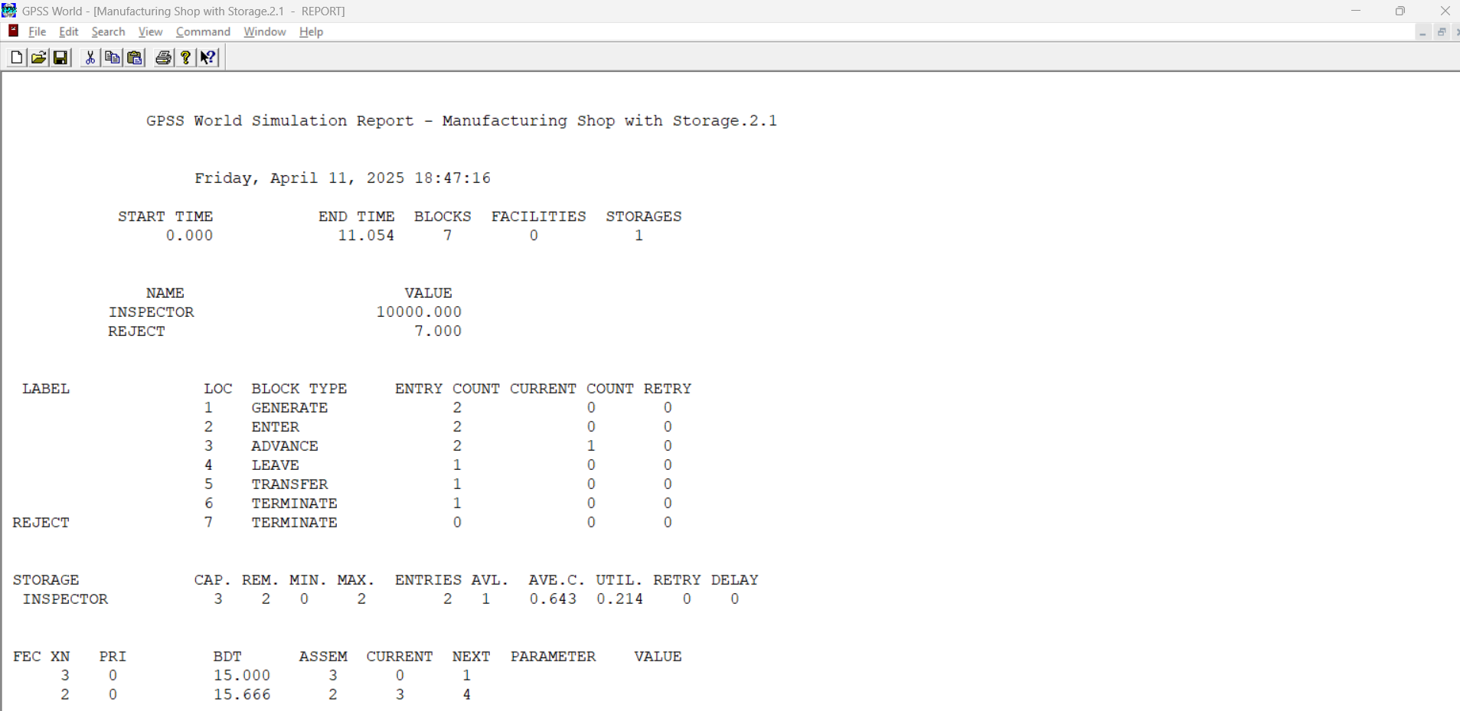

**Q.2. Fuel Station Simulation: One vehicle arrives every 2±2 minutes. It takes 5±2 minutes to fuel one vehicle. Number of nozzles = 2. Fuel station operates 10 hours a day. Write a GPSS program to simulate operation of fuel station for entire day.**

**Source Code:**

GENERATE 2,2

QUEUE FUELQ

ENTER NOZZLE,1

DEPART FUELQ

ADVANCE 5,2

LEAVE NOZZLE,1

TERMINATE 1

NOZZLE STORAGE 2

START 600

**Output:**

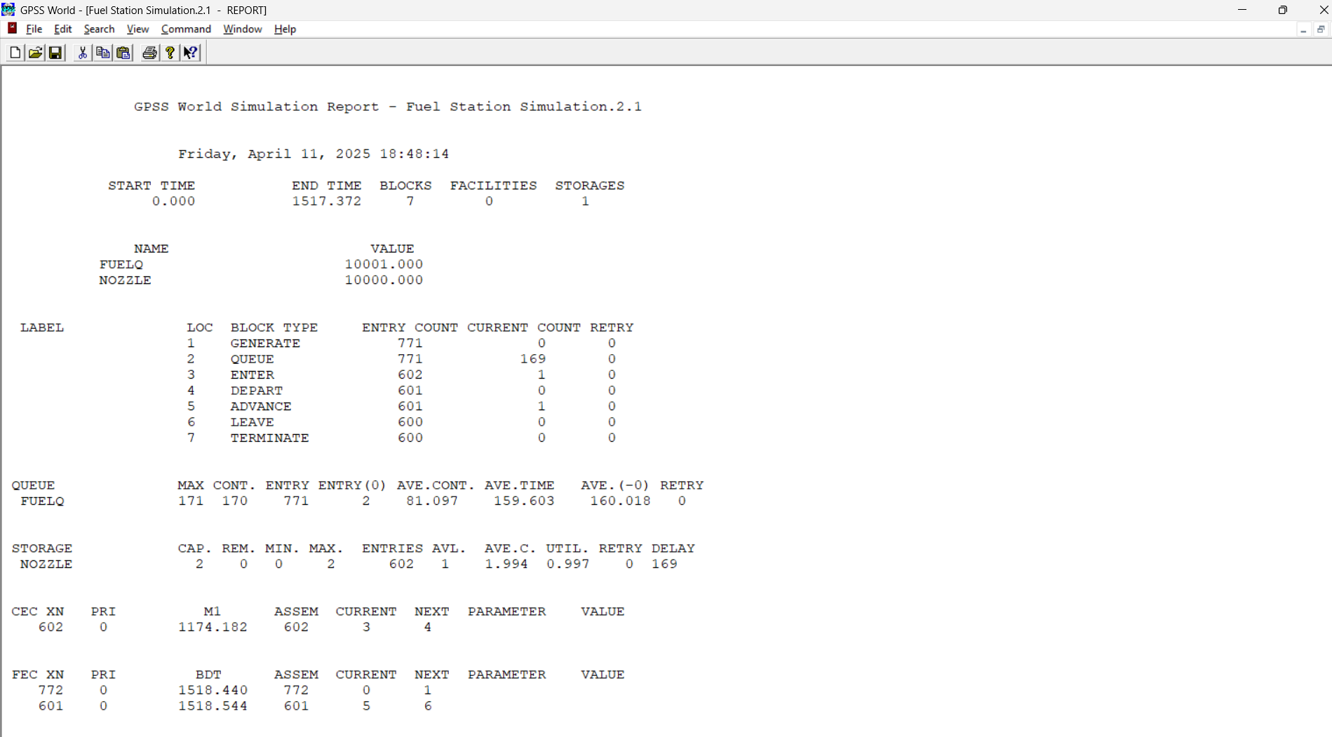

**Conclusion**

The lab demonstrates the use of GPSS simulations to analyze real-world systems, such as a manufacturing process and a fuel station, by modeling service and inspection workflows. Through these simulations, we can assess system performance, identify bottlenecks, and optimize resource allocation. In the manufacturing scenario, multiple inspectors process parts with variable inspection times and rejection rates, while the fuel station scenario model’s random vehicle arrivals and limited-service nozzles. By examining how these systems handle varying loads and conditions, the lab provides insights into improving service efficiency, reducing wait times, and enhancing overall system performance.